One on One planning sheet

Team Member:
Date: | Time:
Last 1:1 date
Department:
Personal/Notes:
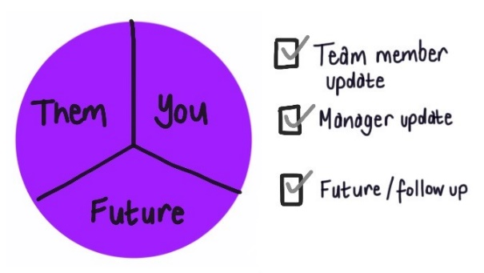
Start with outlining the format for the one-on-one and your overall goals for the conversation. Invite your team member to share their goals for the session.

Agree the first third of the discussion will be initiated by the team member, the next by the manager, then the final third will be a discussion of the future.

Team Member update

Key notes taken during the meeting

Manager update
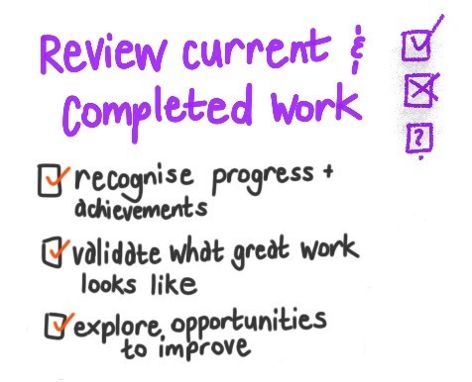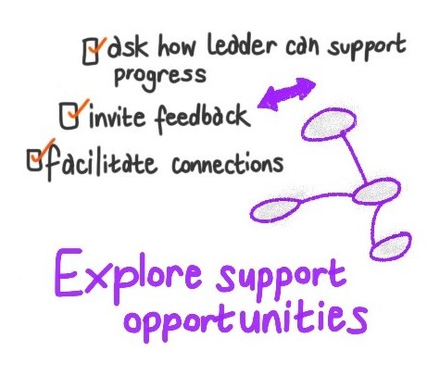
And if your direct report leads others, make sure you check in with how their team are going, what their future work involves, what future development is planned for them, and how you can support them (directly or indirectly).

If not already covered in the team member update, make sure you consider these topics. You may also have some information to share with the team member.
Identify dot points about what you wish to cover:

Notes to prepare for your portion of the meeting

Future – work and development needs

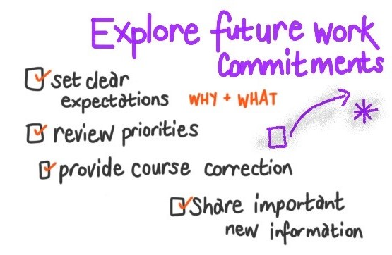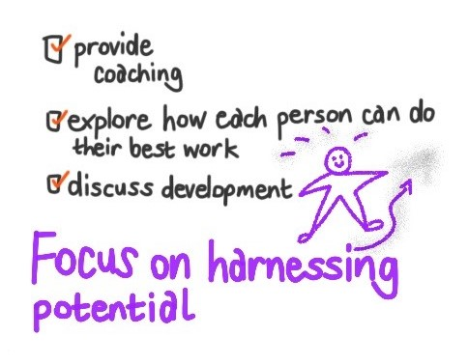

Future focus and actions. What to review next time?

